Title (style: Heading 1)
Peter Black (style: Author and Name), black@where.and.where (style: Author and Name + Not Bold, Italic)
Dept of Informatics Education, Comenius University, try to fit it all in 1 line (style: Address)
Andrea White, white@there.and.there
Dept of Informatics Education, Comenius University, try to fit it all in 1 line

Ignite Poster Abstract
Write the abstract and the paper body in Normal style. Please format pictures with style: Figure. Add a caption for each picture, formatted with Figure caption style.
You can add figures and tables in the extended abstract that best represent your work. We recommend a maximum of two. Your title, author information, abstract, and images should use up to a maximum of two pages. If you do not need a whole page, leave the remaining space blank.
The abstract should:
- Clearly identify the problem being addressed.
- Make relevant links to theory, policy, evidence, etc to support claims, aims, hypothesis, etc.
- Plainly stated objectives (of research or practice activity) with research questions (as appropriate).
- Provide a brief description of any learning activity design and implementation and/or technical solution demonstrating how it is aligned with constructionism and other relevant theories etc.
- Outline research context, data collection and analysis approaches.
- Present preliminary results.
- Identify potential implications of the study for practitioners/policy/research and our developing understanding of constructionism.

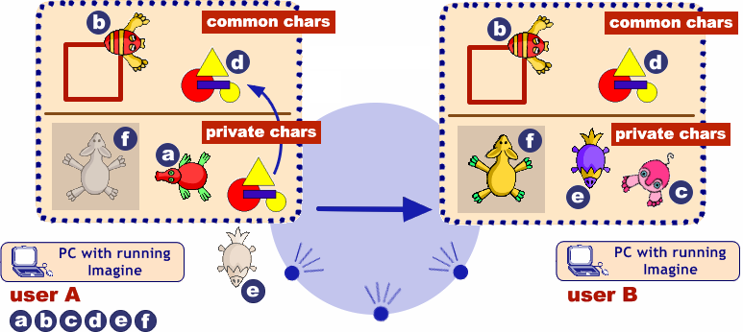
Figure 1. Sending and receiving common and private characters (style: Figure caption)
The quick brown fox jumps over the lazy dog. The quick brown fox jumps over the lazy dog. The quick brown fox jumps over the lazy dog. The quick brown fox jumps over the lazy dog. The quick brown fox jumps over the lazy dog. The quick brown fox jumps over the lazy dog. The quick brown fox jumps over the lazy dog. The quick brown fox jumps over the lazy dog. The quick brown fox jumps over the lazy dog. The quick brown fox jumps over the lazy dog. The quick brown fox jumps over the lazy dog.

References (Please use the APA citation style)
Salanci, L. (2001) Networking in Logo (style: Normal + Italic). In Proceedings of EuroLogo 2001. Edited by G. Futschek. Linz, August. pp. 67 − 74. (style: Normal)
Kalas, I. and Winczer, M. (2007) Building interfaces for on-line collaborative learning. Journal of Environmental Science, 84, 161−175.
Jones, A. B. and Smith, W. (1984) Statistical Methods for Scientists. Wiley, New York.
Galik, Z. (2007) Contributions to the theory of order statistics. Ph.D. thesis, Comenius University, Bratislava.

Information for organisers
Use this page to provide as much additional information as necessary for the conference organisers to facilitate your workshop. This should include the following as a minimum:
- Who the target audience is
- The maximum number of attendees
- Any equipment that will be required (including who you expect to supply it)
- Whether there are any requirements regarding the physical space (providing a photograph or diagram may help here)

