Title (style: Heading 1)
Peter Black (style: Author and Name), black@where.and.where (style: Author and Name + Not Bold, Italic)
Dept of Informatics Education, Comenius University, try to fit it all in 1 line (style: Address)
Andrea White, white@there.and.there
Dept of Informatics Education, Comenius University, try to fit it all in 1 line

Abstract (style: Abstract title)
Write the abstract and the paper body in Normal style. Please format pictures with style: Figure. Add a caption for each picture, formatted with Figure caption style.
You can add one picture in the abstract that best represents your work. Your title, author information, abstract, picture, and keywords should use up the entire first page. If you do not need the whole page, leave the remaining space blank. The abstract must not proceed to the second page. Continue your paper contents on page two.
The abstract should include a problem statement, aim of the paper, research questions, outline of the study/practice activity/theoretical ideas, key findings and contribution (as appropriate).
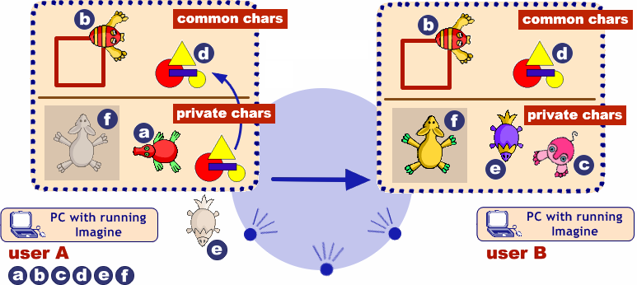
Figure 1. Sending and receiving common and private characters (style: Figure caption)
The quick brown fox jumps over the lazy dog. The quick brown fox jumps over the lazy dog. The quick brown fox jumps over the lazy dog. The quick brown fox jumps over the lazy dog. The quick brown fox jumps over the lazy dog. The quick brown fox jumps over the lazy dog. The quick brown fox jumps over the lazy dog. The quick brown fox jumps over the lazy dog. The quick brown fox jumps over the lazy dog. The quick brown fox jumps over the lazy dog. The quick brown fox jumps over the lazy dog.

Keywords (style: Keywords)
5-7 keywords (style: Normal)

Heading (style: Heading 2)
Text (style: Normal)
The quick brown fox jumps over the lazy dog. The quick brown fox jumps over the lazy dog. The quick brown fox jumps over the lazy dog. The quick brown fox jumps over the lazy dog. The quick brown fox jumps over the lazy dog. The quick brown fox jumps over the lazy dog. The quick brown fox jumps over the lazy dog. The quick brown fox jumps over the lazy dog. The quick brown fox jumps over the lazy dog.

Sub heading (style: Heading 3)
The quick brown fox jumps over the lazy dog. The quick brown fox jumps over the lazy dog. The quick brown fox jumps over the lazy dog. The quick brown fox jumps over the lazy dog. The quick brown fox jumps over the lazy dog.The quick brown fox jumps over the lazy dog. The quick brown fox jumps over the lazy dog. The quick brown fox jumps over the lazy dog. The quick brown fox jumps over the lazy dog. The quick brown fox jumps over the lazy dog. The quick brown fox jumps over the lazy dog.
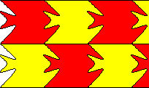
Figure 2. Tessellation (style: Figure caption)

Heading

Sub heading
The quick brown fox jumps over the lazy dog. The quick brown fox jumps over the lazy dog. The quick brown fox jumps over the lazy dog. The quick brown fox jumps over the lazy dog. The quick brown fox jumps over the lazy dog.
- fusce varius nisl at dolor (style: bullet)
- donec rutrum laoreet mi (style: bullet)
- present posuere pretium libero (style: bullet)
- sed dapibus commodo orci (style: bullet)

References (Please use the APA citation style)
Salanci, L. (2001) Networking in Logo (style: Normal + Italic). In Proceedings of EuroLogo 2001. Edited by G. Futschek. Linz, August. pp. 67 − 74. (style: Normal)
Kalas, I. and Winczer, M. (2007) Building interfaces for on-line collaborative learning. Journal of Environmental Science, 84, 161−175.
Jones, A. B. and Smith, W. (1984) Statistical Methods for Scientists. Wiley, New York.
Galik, Z. (2007) Contributions to the theory of order statistics. Ph.D. thesis, Comenius University, Bratislava.

