Title (style: Heading 1)
Author1FirstName SecondName (style: Author and Name), name@where.and.where (style: Author and Name + Not Bold, Italic) DO NOT PROVIDE NAMES ETC FOR BLIND REVIEW
Dept of XYZ, University of XYX, City, Country, try to fit it all in 1 line (style: Address)
Author2FirstName SecondName (style: Author and Name), name@where.and.where (style: Author and Name + Not Bold, Italic) DO NOT PROVIDE NAMES ETC FOR BLIND REVIEW
Dept of XYZ, University of XYX, City, Country, try to fit it all in 1 line (style: Address)

Abstract (style: Abstract title)
Write the abstract and the paper body in Normal style. Please format pictures with style: Figure. Add a caption for each picture, formatted with Figure caption style.
You can add one picture in the abstract that best represents your work. Your title, author information, abstract, and picture should use up the entire first page. If you do not need the whole page, leave the remaining space blank. The abstract must not proceed to the second page. Additional information that needs only to be communicated to the conference organisers should be given on page 2.
The abstract should include a brief description of the activity, the key ideas which underpin in and an explanation of how the activity will be beneficial to participants and who those participants might be.
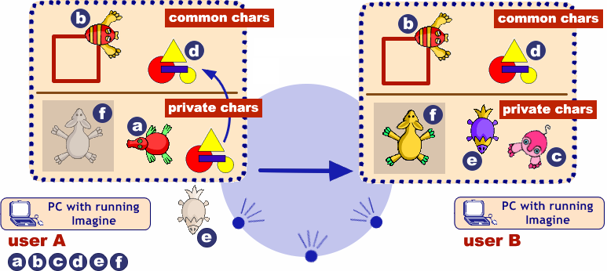
Figure 1. Sending and receiving common and private characters (style: Figure caption)
The quick brown fox jumps over the lazy dog. The quick brown fox jumps over the lazy dog. The quick brown fox jumps over the lazy dog. The quick brown fox jumps over the lazy dog. The quick brown fox jumps over the lazy dog. The quick brown fox jumps over the lazy dog. The quick brown fox jumps over the lazy dog. The quick brown fox jumps over the lazy dog. The quick brown fox jumps over the lazy dog. The quick brown fox jumps over the lazy dog. The quick brown fox jumps over the lazy dog.

Information for organisers
Use this page to provide as much additional information as necessary for the conference organisers to facilitate your workshop. This should include the following as a minimum:
- Who the target audience is
- The maximum number of attendees
- Any equipment that will be required (including who you expect to supply it)
- Whether there are any requirements regarding the physical space (providing a photograph or diagram may help here)

